Angle Addition Theorem
# Source: AI Source: Provided by: [Data Path: Persons Table -> ID Column: 1, Name_En Column: Motasem Essam] -> From: [ChatGPT] on [7/25/2026]
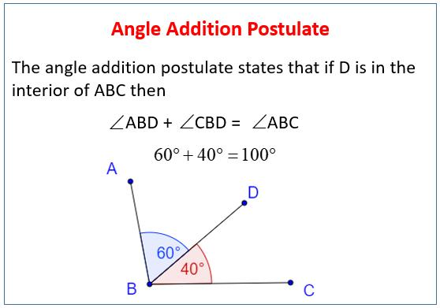
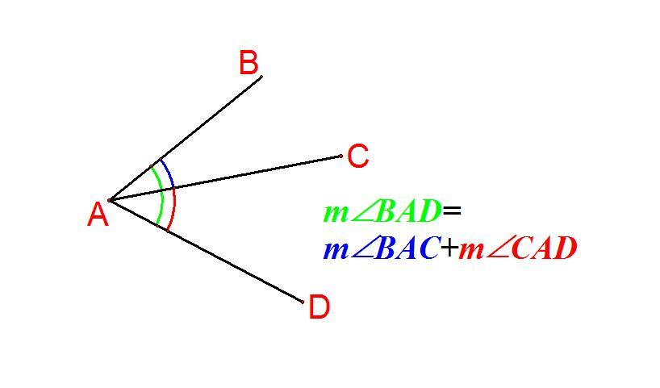
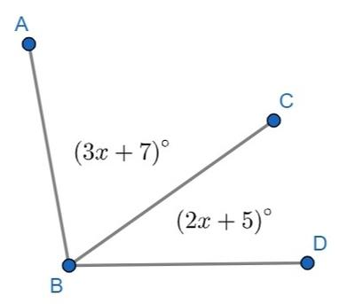

Definition
# Source: AI Source: Provided by: [Data Path: Persons Table -> ID Column: 1, Name_En Column: Motasem Essam] -> From: [ChatGPT] on [7/25/2026]
The Angle Addition Theorem, also commonly called the Angle Addition Postulate, states that:
If a ray lies in the interior of an angle, then the measures of the two smaller adjacent angles add up to the measure of the original whole angle.
For example, if ray $\vec{BC}$ lies inside $∠ABD$, then:
$$\boxed{m∠ABC+m∠CBD=m∠ABD}$$
Here:
- $∠ABC$ → first smaller angle
- $∠CBD$ → second smaller angle
- $∠ABD$ → whole angle

Purpose
# Source: AI Source: Provided by: [Data Path: Persons Table -> ID Column: 1, Name_En Column: Motasem Essam] -> From: [ChatGPT] on [7/25/2026]
The Angle Addition Theorem is used to:
- Find an unknown angle measure.
- Combine adjacent angles.
- Divide a larger angle into smaller angles.
- Solve algebraic equations involving angles.
- Establish relationships between angles.
- Work with angle bisectors and special angle pairs.

Basic Configuration
# Source: AI Source: Provided by: [Data Path: Persons Table -> ID Column: 1, Name_En Column: Motasem Essam] -> From: [ChatGPT] on [7/25/2026]
Suppose ray $\vec{BC}$ lies inside $∠ABD$:
$$A ∖ C / B→D$$
The whole angle is divided into two adjacent angles:
$$∠ABC$$
and
$$∠CBD$$
Therefore:
$\boxed{m∠ABC+m∠CBD=m∠ABD}$
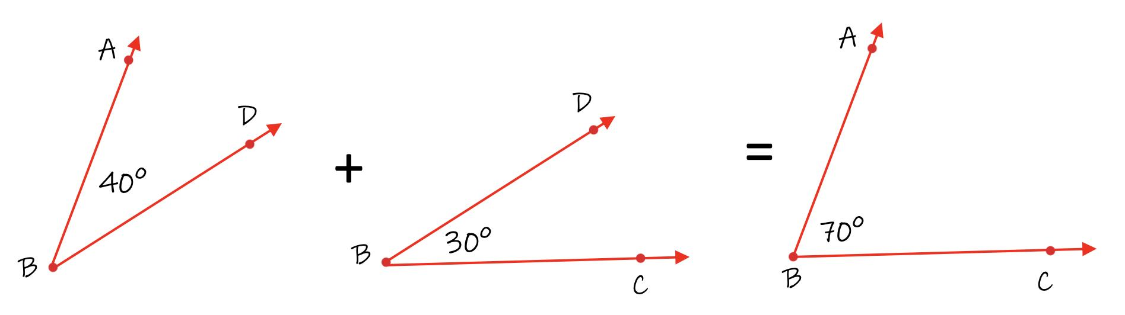

Mathematical Representation
# Source: AI Source: Provided by: [Data Path: Persons Table -> ID Column: 1, Name_En Column: Motasem Essam] -> From: [ChatGPT] on [7/25/2026]
The fundamental relationship is:
$$\boxed{m∠ABC+m∠CBD=m∠ABD}$$
It can also be rearranged:
$$\boxed{m∠ABC=m∠ABD-m∠CBD}$$
or:
$$\boxed{m∠CBD=m∠ABD-m∠ABC}$$
So:
$$\boxed{\text{Whole Angle}=\text{Part 1}+\text{Part 2}}$$

Example 1 — Finding the Whole Angle
# Source: AI Source: Provided by: [Data Path: Persons Table -> ID Column: 1, Name_En Column: Motasem Essam] -> From: [ChatGPT] on [7/25/2026]
Suppose:
$$m∠ABC={35}^{∘}$$
and:
$$m∠CBD={45}^{∘}$$
Find:
$$m∠ABD$$
Using the Angle Addition Theorem:
$$m∠ABC+m∠CBD=m∠ABD$$
Substitute:
$${35}^{∘}+{45}^{∘}=m∠ABD$$
Therefore:
$$\boxed{m∠ABD={80}^{∘}}$$

Example 2 — Finding a Missing Part
# Source: AI Source: Provided by: [Data Path: Persons Table -> ID Column: 1, Name_En Column: Motasem Essam] -> From: [ChatGPT] on [7/25/2026]
Suppose:
$$m∠ABD={120}^{∘}$$
and:
$$m∠ABC={70}^{∘}$$
Find:
$$m∠CBD$$
Using:
$$m∠ABC+m∠CBD=m∠ABD$$
Substitute:
$${70}^{∘}+m∠CBD={120}^{∘}$$
Therefore:
$m∠CBD={120}^{∘}-{70}^{∘}$ $\boxed{m∠CBD={50}^{∘}}$

Example 3 — Algebraic Angles
# Source: AI Source: Provided by: [Data Path: Persons Table -> ID Column: 1, Name_En Column: Motasem Essam] -> From: [ChatGPT] on [7/25/2026]
Suppose:
$m∠ABC=2x+10$ $m∠CBD=3x-5$
and:
$$m∠ABD={80}^{∘}$$
Using the theorem:
$$(2x+10)+(3x-5)=80$$
Simplify:
$5x+5=80$ $5x=75$ $x=15$
Now calculate each angle:
$m∠ABC=2(15)+10={40}^{∘}$ $m∠CBD=3(15)-5={40}^{∘}$
Check:
$${40}^{∘}+{40}^{∘}={80}^{∘}$$
Therefore:
$$\boxed{x=15}$$
and:
$$\boxed{m∠ABC={40}^{∘}, m∠CBD={40}^{∘}}$$

Example 4 — Three Adjacent Angles
# Source: AI Source: Provided by: [Data Path: Persons Table -> ID Column: 1, Name_En Column: Motasem Essam] -> From: [ChatGPT] on [7/25/2026]
The theorem can be extended to more than two adjacent angles.
Suppose an angle is divided into three parts:
$$∠ABC, ∠CBD, ∠DBE$$
Then:
$$\boxed{m∠ABC+m∠CBD+m∠DBE=m∠ABE}$$
For example:
$${25}^{∘}+{35}^{∘}+{40}^{∘}={100}^{∘}$$
Therefore:
$$\boxed{m∠ABE={100}^{∘}}$$

Angle Addition and Angle Bisectors
# Source: AI Source: Provided by: [Data Path: Persons Table -> ID Column: 1, Name_En Column: Motasem Essam] -> From: [ChatGPT] on [7/25/2026]
An angle bisector divides an angle into two congruent angles.
If ray $\vec{BC}$ bisects $∠ABD$, then:
$$m∠ABC=m∠CBD$$
Using the Angle Addition Theorem:
$$m∠ABC+m∠CBD=m∠ABD$$
Since the two angles are equal:
$$2m∠ABC=m∠ABD$$
Therefore:
$$\boxed{m∠ABC=m∠CBD=\frac{1}{2}m∠ABD}$$
Example
If:
$$m∠ABD={90}^{∘}$$
and $BC$ is its angle bisector:
$$m∠ABC=m∠CBD$$
Therefore:
$$m∠ABC=m∠CBD={45}^{∘}$$

Special Cases

1. Right Angle
# Source: AI Source: Provided by: [Data Path: Persons Table -> ID Column: 1, Name_En Column: Motasem Essam] -> From: [ChatGPT] on [7/25/2026]
If the whole angle is a right angle:
$$m∠ABD={90}^{∘}$$
then:
$$\boxed{m∠ABC+m∠CBD={90}^{∘}}$$

2. Straight Angle
# Source: AI Source: Provided by: [Data Path: Persons Table -> ID Column: 1, Name_En Column: Motasem Essam] -> From: [ChatGPT] on [7/25/2026]
If the whole angle is a straight angle:
$$m∠ABD={180}^{∘}$$
then:
$$\boxed{m∠ABC+m∠CBD={180}^{∘}}$$
This is closely related to supplementary angles.

3. Full Angle
# Source: AI Source: Provided by: [Data Path: Persons Table -> ID Column: 1, Name_En Column: Motasem Essam] -> From: [ChatGPT] on [7/25/2026]
If the angles together form a complete rotation:
$$m∠={360}^{∘}$$
then:
$$\boxed{\text{sum of all parts}={360}^{∘}}$$

Relationship with Segment Addition
# Source: AI Source: Provided by: [Data Path: Persons Table -> ID Column: 1, Name_En Column: Motasem Essam] -> From: [ChatGPT] on [7/25/2026]
The Angle Addition Theorem works similarly to the Segment Addition Theorem.
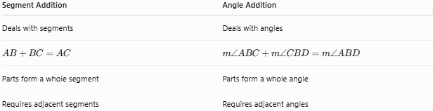
Segment Addition | Angle Addition
Deals with segments | Deals with angles
$$AB+BC=AC$$ | $$m∠ABC+m∠CBD=m∠ABD$$
Parts form a whole segment | Parts form a whole angle
Requires adjacent segments | Requires adjacent angles
The basic idea is the same:
$$\boxed{\text{Whole}=\text{Part 1}+\text{Part 2}}$$

Relationship with Other Angle Concepts
# Source: AI Source: Provided by: [Data Path: Persons Table -> ID Column: 1, Name_En Column: Motasem Essam] -> From: [ChatGPT] on [7/25/2026]
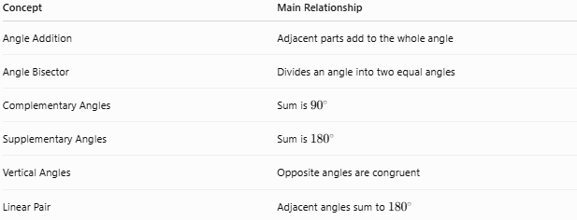
Concept | Main Relationship
Angle Addition | Adjacent parts add to the whole angle
Angle Bisector | Divides an angle into two equal angles
Complementary Angles | Sum is ${90}^{∘}$
Supplementary Angles | Sum is ${180}^{∘}$
Vertical Angles | Opposite angles are congruent
Linear Pair | Adjacent angles sum to ${180}^{∘}$

Proof / Reasoning
# Source: AI Source: Provided by: [Data Path: Persons Table -> ID Column: 1, Name_En Column: Motasem Essam] -> From: [ChatGPT] on [7/25/2026]
Suppose ray $\vec{BC}$ lies inside $∠ABD$.
The ray divides the whole angle into two non-overlapping adjacent regions:
$$∠ABC$$
and:
$$∠CBD$$
Together, these two regions exactly fill $∠ABD$.
Therefore, their measures must add:
$$\boxed{m∠ABC+m∠CBD=m∠ABD}$$
This is why the relationship is called angle addition.

Applications
# Source: AI Source: Provided by: [Data Path: Persons Table -> ID Column: 1, Name_En Column: Motasem Essam] -> From: [ChatGPT] on [7/25/2026]
The Angle Addition Theorem is used in:
- Basic geometry.
- Triangle problems.
- Polygon problems.
- Angle-bisector problems.
- Parallel-line problems.
- Coordinate geometry.
- Algebraic geometry problems.
- Construction and drafting.
- Engineering diagrams.
- Architectural drawings.

Common Mistakes

1. Adding angles that are not adjacent
# Source: AI Source: Provided by: [Data Path: Persons Table -> ID Column: 1, Name_En Column: Motasem Essam] -> From: [ChatGPT] on [7/25/2026]
The theorem applies when the smaller angles together form the whole angle.

2. Using the wrong whole angle
# Source: AI Source: Provided by: [Data Path: Persons Table -> ID Column: 1, Name_En Column: Motasem Essam] -> From: [ChatGPT] on [7/25/2026]
Always identify the two outer rays of the entire angle.
For:
$$∠ABC+∠CBD$$
the whole angle is:
$$∠ABD$$
not $∠ABC$ or $∠CBD$.

3. Forgetting the degree symbol
# Source: AI Source: Provided by: [Data Path: Persons Table -> ID Column: 1, Name_En Column: Motasem Essam] -> From: [ChatGPT] on [7/25/2026]
Angle measures should normally be expressed in degrees:
$${45}^{∘}$$
rather than simply $45$, when giving the final geometric measure.

Comparison with Segment Addition Theorem
# Source: AI Source: Provided by: [Data Path: Persons Table -> ID Column: 1, Name_En Column: Motasem Essam] -> From: [ChatGPT] on [7/25/2026]
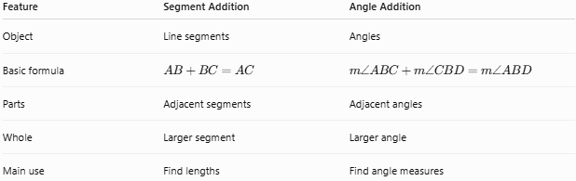
Feature | Segment Addition | Angle Addition
Object | Line segments | Angles
Basic formula | $$AB+BC=AC$$ | $$m∠ABC+m∠CBD=m∠ABD$$
Parts | Adjacent segments | Adjacent angles
Whole | Larger segment | Larger angle
Main use | Find lengths | Find angle measures

Key Points
# Source: AI Source: Provided by: [Data Path: Persons Table -> ID Column: 1, Name_En Column: Motasem Essam] -> From: [ChatGPT] on [7/25/2026]
- The Angle Addition Theorem combines adjacent angles.
- If a ray divides an angle into two parts:
$$\boxed{m∠ABC+m∠CBD=m∠ABD}$$
- The whole angle equals the sum of its parts.
- It can be extended to three or more adjacent angles.
- It is especially useful with angle bisectors.
- It is analogous to the Segment Addition Theorem.
- A straight angle gives a total of ${180}^{∘}$.
- A right angle gives a total of ${90}^{∘}$.
- A complete angle gives a total of ${360}^{∘}$.

Conclusion
# Source: AI Source: Provided by: [Data Path: Persons Table -> ID Column: 1, Name_En Column: Motasem Essam] -> From: [ChatGPT] on [7/25/2026]
The Angle Addition Theorem is a fundamental principle of geometry stating that when a ray divides an angle into adjacent parts, the measures of those parts add to the measure of the whole angle:
$$\boxed{\text{Whole Angle}=\text{Sum of Its Parts}}$$
or, specifically:
$$\boxed{m∠ABC+m∠CBD=m∠ABD}$$
It is one of the fundamental tools for solving angle-measure problems and is closely connected to angle bisectors, complementary and supplementary angles, and other geometric relationships.

